# **NAME: MUHAMMAD MUBASHIR**

# **FATHER NAME: SAEED AKBER**

# **COURSE: MOBILE APPLICATION**

# **COURSE INSTRUCTOR: SALMAN BEDIYA**

# ***Assignment 2***

1. Write a program to check if a given string is a palindrome.

void main(){

checkpalindrome("civic")? print("its is palindrome word") :

print("its is not palindrome word");

checkpalindrome("hello")? print("its is palindrome word") :

print("its is not palindrome word");

checkpalindrome("abba")? print("its is palindrome word") :

print("its is not palindrome word");

checkpalindrome("")? print("its is palindrome word") : print("its is not palindrome word"); checkpalindrome("amma")? print("its is palindrome word") :

print("its is not palindrome word");

}

bool checkpalindrome(String user){

return user == user.split("").reversed.join();

}

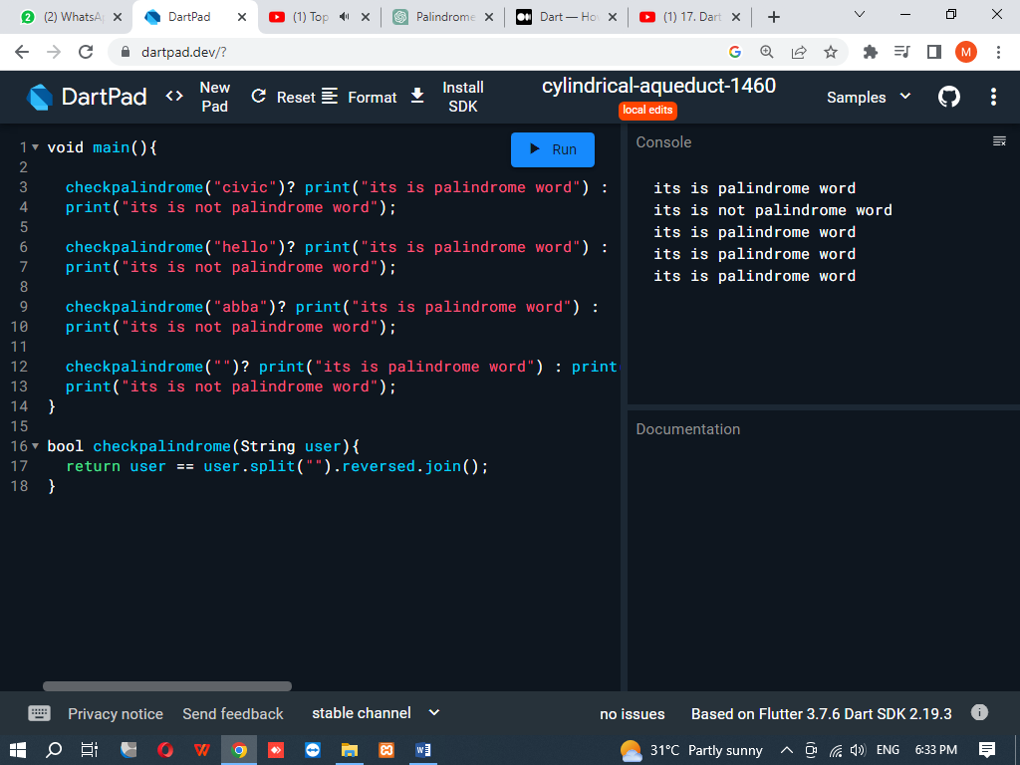

1. Write a program to calculate the factorial of a given number using a function.

void main()

{

factorial(8);

}

void factorial(int a)

{

int fact=1;

for(int i=1; i<=a; i++){

fact=fact*i;

}

print("The factorial of $a is $fact");

}

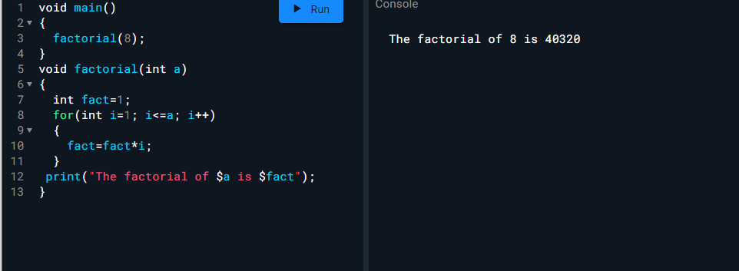

1. Write a program to print out the Fibonacci sequence up to a given number.

void main() {

fibonacci(55);

}

void fibonacci(int a){

int b = 0;

int c = 1;

int d;

print('Fibonacci sequence up to $a:');

print(b);

print(c);

for (int i = 2; i <=a; i++) {

d = b + c;

if (c > a) {

break;

}

print(c);

b = c;

c = d;

}

}

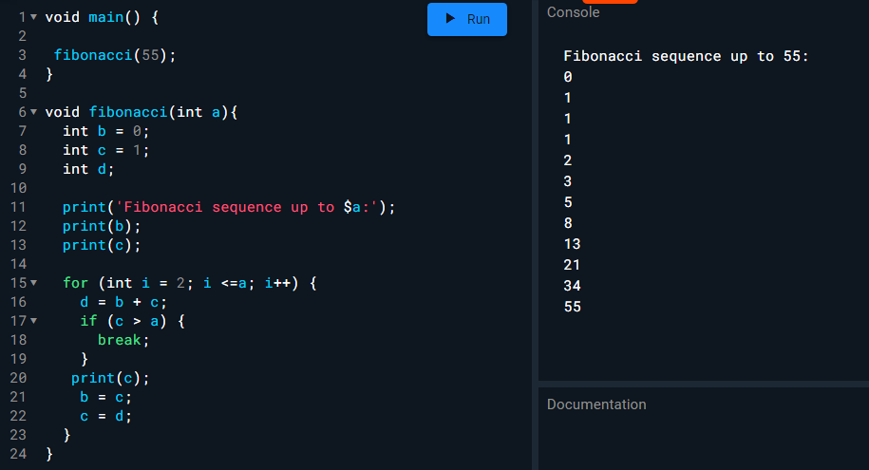

**4. Write a program to calculate the distance between two points on a 2D plane using a function.**

import 'dart:math';

void main() {

// example coordinates

var point1 = Point(3, 5);

var point2 = Point(1, 9);

var distance = calculateDistance(point1, point2);

print('The distance between $point1 and $point2 is $distance');

}

double calculateDistance(Point p1, Point p2) {

var xDiff = p2.x - p1.x;

var yDiff = p2.y - p1.y;

var distance = sqrt(pow(xDiff, 2) + pow(yDiff, 2));

return distance;

}

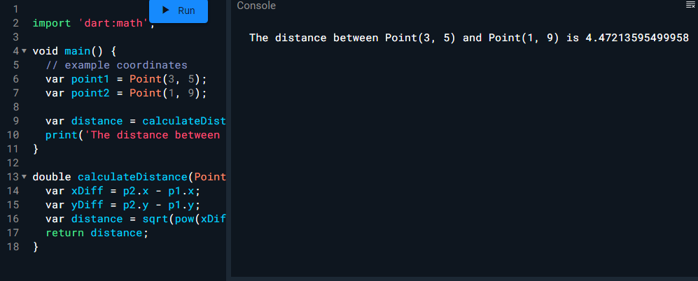

**5. Write a program to convert a temperature from Fahrenheit to Celsius using a function**

void main() {

// example Fahrenheit temperature

dynamic fahrenheit=90;

var celsius = convertFahrenheitToCelsius(fahrenheit);

print('$fahrenheit°F is equal to $celsius°C');

}

double convertFahrenheitToCelsius(double fahrenheit) {

var celsius = (fahrenheit - 32) * 5 / 9;

return celsius;

}

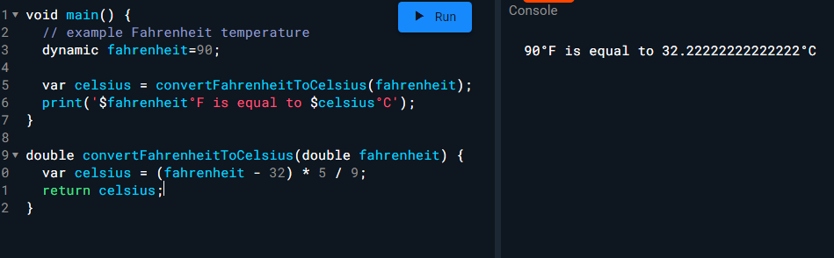

1. **Write a program to calculate the area of a circle using a function.**

import 'dart:math';

void main() {

// example circle radius

dynamic radius = 10;

var area = calculateCircleArea(radius);

print('The area of a circle with radius $radius is $area');

}

double calculateCircleArea(double radius) {

var area = pi * pow(radius, 2);

return area;

}

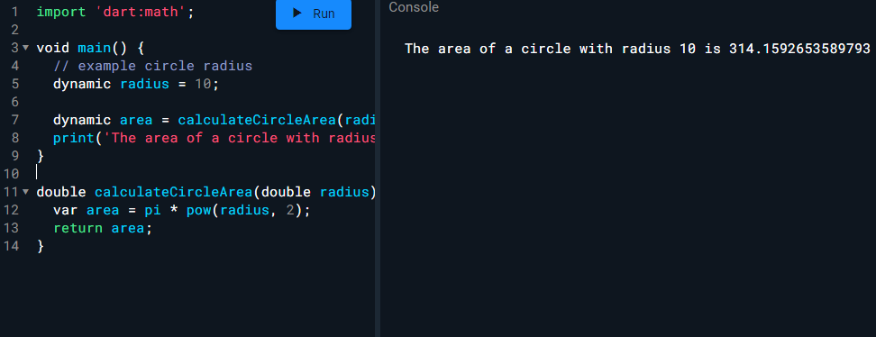

**7. Write a program to print out the prime numbers between 1 and a given number.**

import 'dart:math';

void main() {

// example upper limit

var limit = 30;

print('The prime numbers between 1 and $limit are:');

for (var i = 2; i <= limit; i++) {

if (isPrime(i)) {

print(i);

}

}

}

bool isPrime(int number) {

if (number <= 1) {

return false;

}

for (var i = 2; i <= sqrt(number); i++) {

if (number % i == 0) {

return false;

}

}

return true;

}

